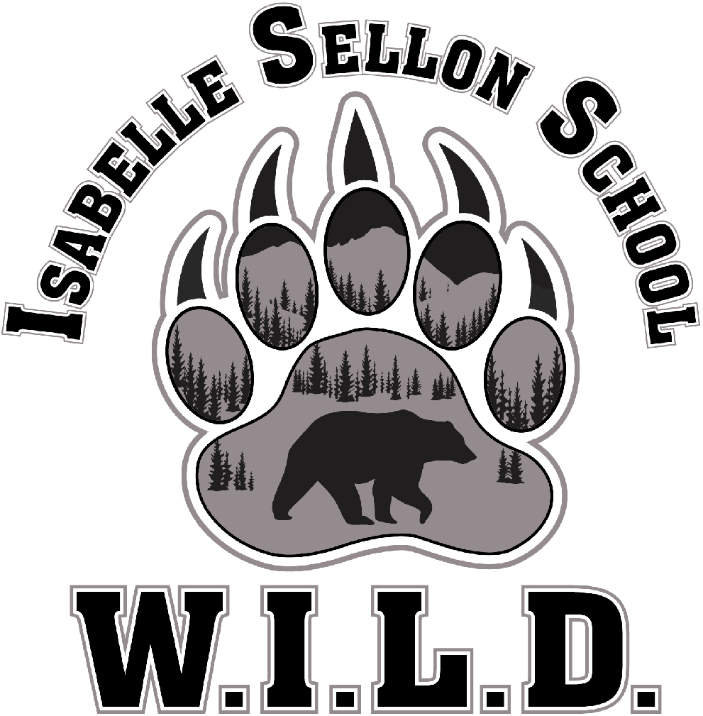
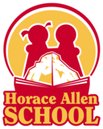

LIVINGSTONE RANGE SCHOOL DIVISION NO. 68
TRI-SCHOOL COUNCIL MEETING

Facilitator: Paul Pichurski, CCHS
Recorder: Paul Pichurski
Attendance:

Item | Information  Discussion  Activity | Owner
Acknowledgement of Land - Oki, welcome to our school located on the traditional land and territory of the Niitsitapi (Piikani, Kainai and Siksika- the “Blackfoot People”) within the Treaty 7 region of Southern Alberta.
Trustee Report:  Greg/Clara - 5 minutes  Board Three Key Message (most recent) | Greg  Review of the attached Key Messages
Admin Reports- 5 minutes per school
HAS
ISS
CCHS
Breakout into individual school councils
HAS
ISS- Sharing of ISS MRA Results, Playground surface update
CCHS - Sharing of CCHS MRA Results
Adjournment: Next meeting: | Tuesday, May 21st - HAS

